**Name : Saksham Kumar Sahu**

**Reg No. : 20BCY10122**

**Assignment -1**

**Kali**

**File and Directory Operations:**

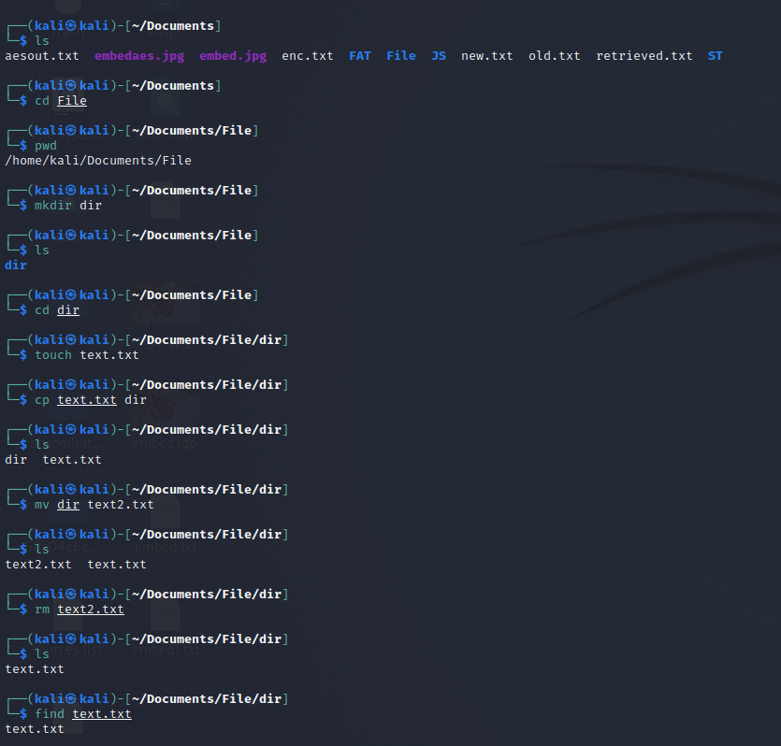

**File Viewing and Editing:**

cat: Concatenate and display file content



less: View file content with pagination



head: Display the beginning of a file



tail: Display the end of a file



nano: Text editor for creating and editing files

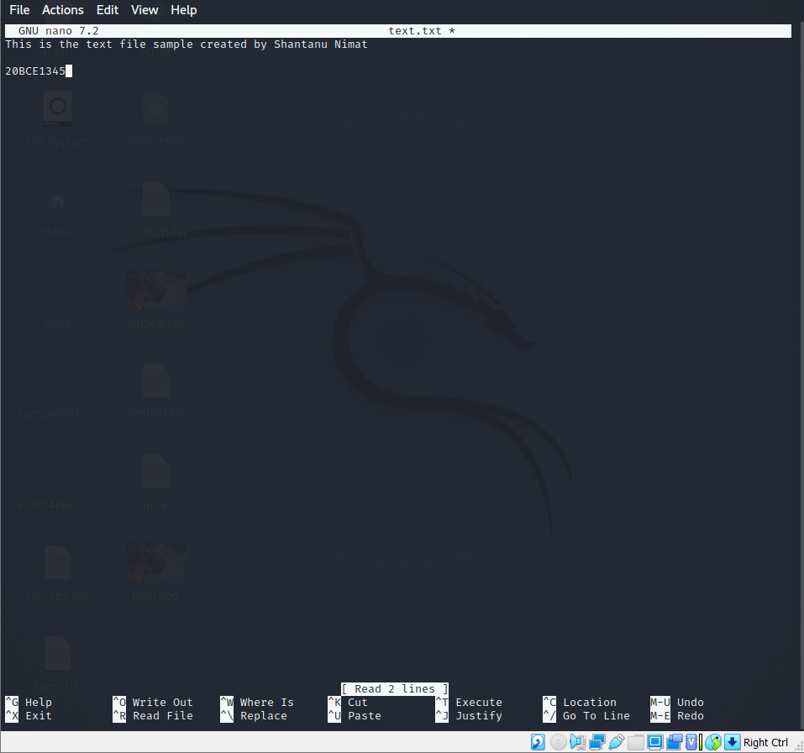

vi/vim: Powerful text editor for experienced users

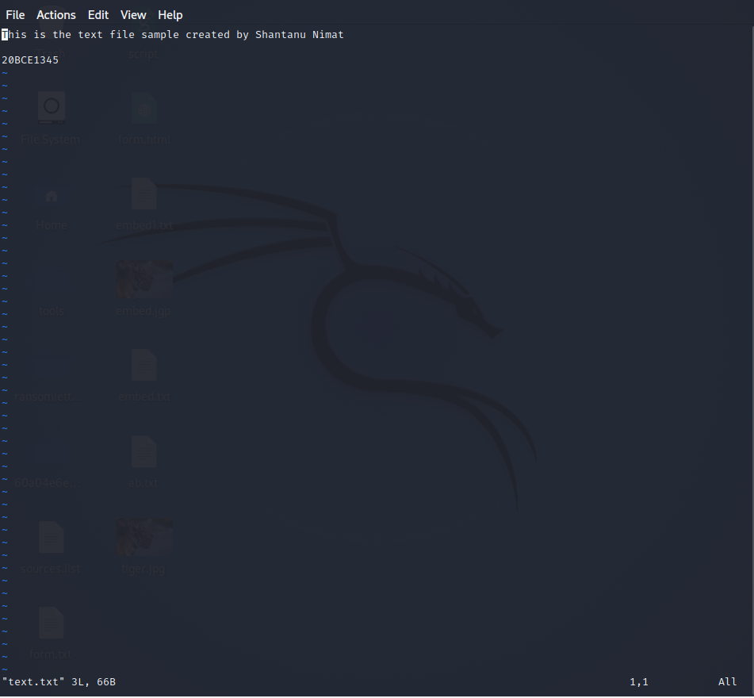

**File Permissions:**

chmod: Change file permissions

It will set the read and write permission for other users of the text files



chown: Change file owner

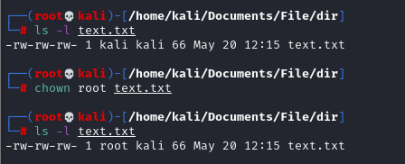

chgrp: Change file group

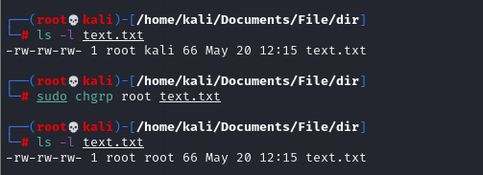

**File Compression and Archiving:**

tar: Archive files

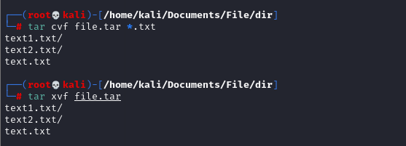

Compressed

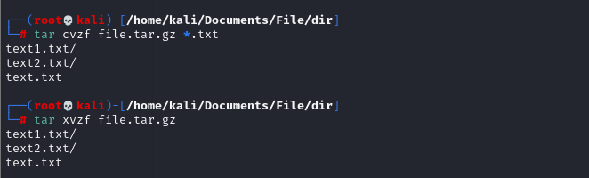

gzip: Compress files



Unzip gzip



Zip and unzip: Extract files from a ZIP archive

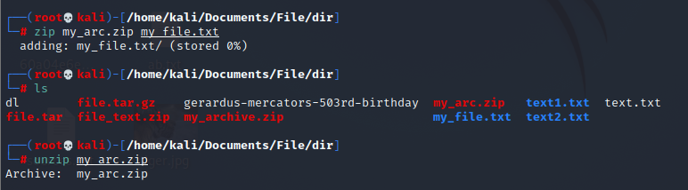

**Process Management:**

ps: List running processes

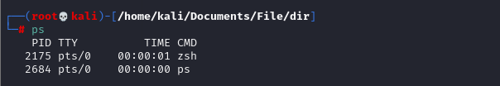

top: Display real-time system information and processes

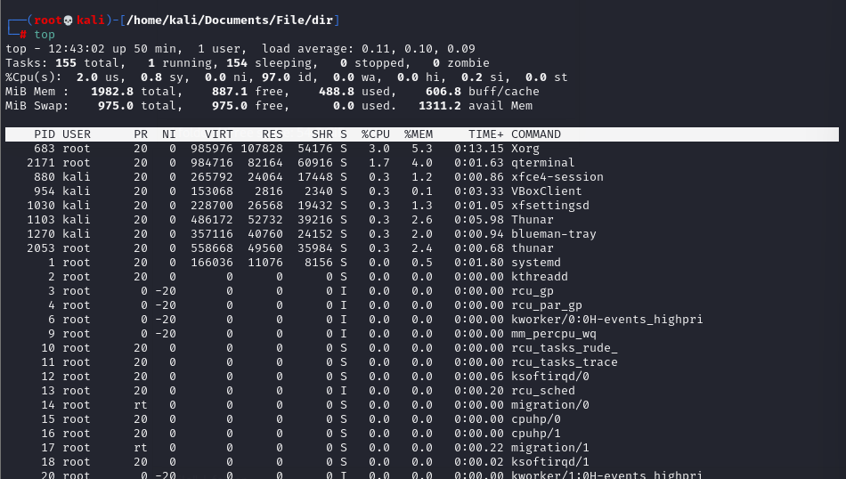

kill: Terminate processes



bg: Run processes in the background

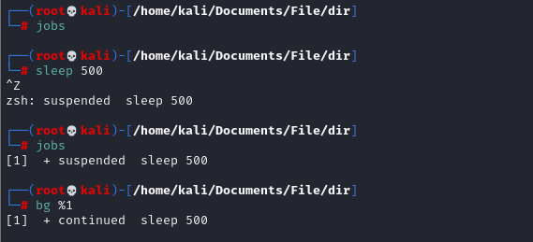

fg: Bring background processes to the foreground



**System Information:**

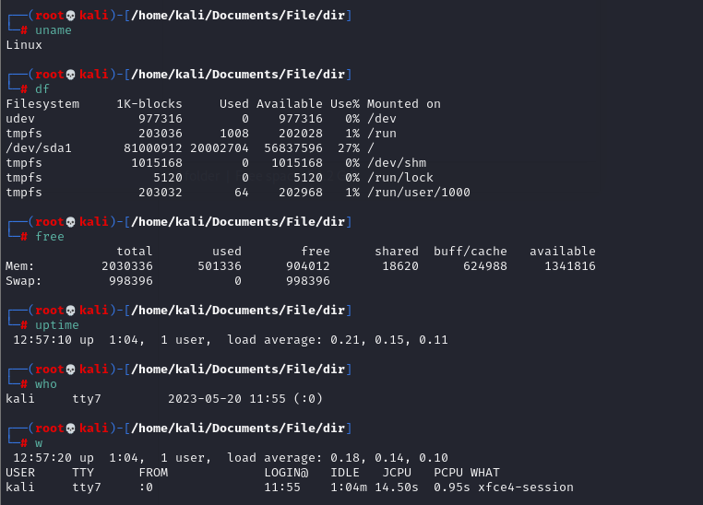

**Networking:**

ifconfig: Configure network interfaces

ping: Send ICMP echo requests to a network host

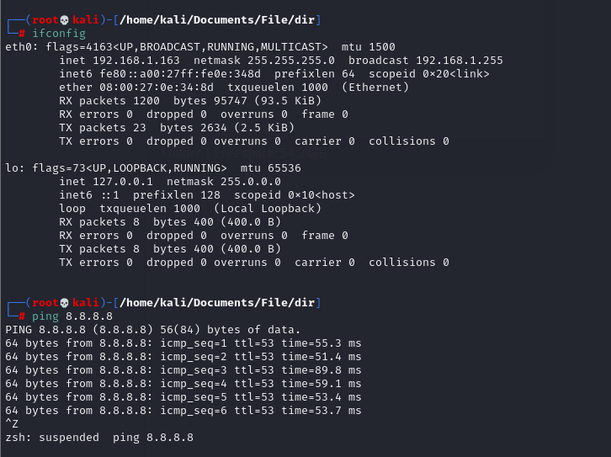

ssh: Securely connect to a remote system

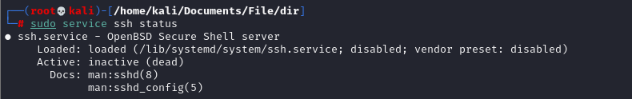

connecting to Metasploitable 2 using ssh

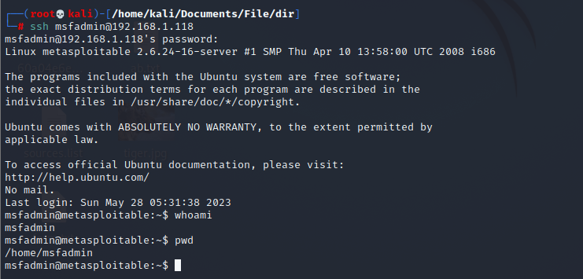

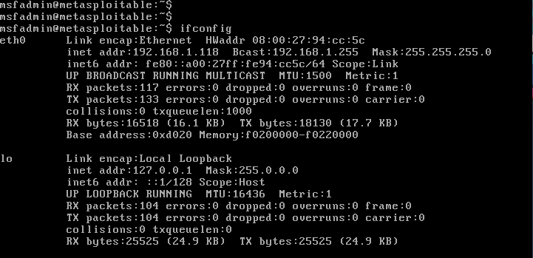

scp: Securely copy files between systems

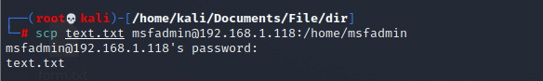

wget: Download files from the web

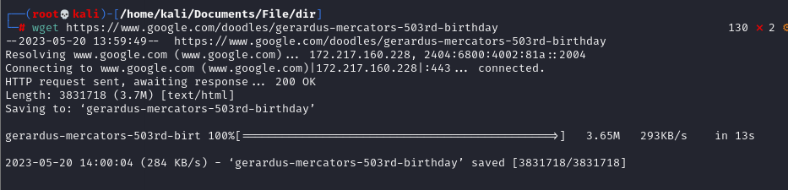

**System Administration:**

sudo: Execute commands with superuser privileges

apt-get: Package management for Debian-based distributions

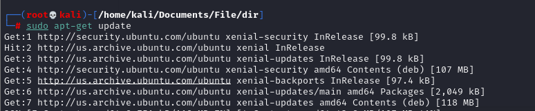

yum: Package management for Red Hat-based distributions

It is used for installing, updating, and managing software packages on the system. Here are some commonly used commands with yum:

Install a package:

sudo yum install <package_name>

Update all installed packages:

sudo yum update

Search for a package:

yum search <keyword>

List installed packages:

yum list installed

Remove a package:

sudo yum remove <package_name>

Clean the cache and free up disk space:

sudo yum clean all

Enable a repository:

sudo yum-config-manager --enable <repository_name>

Disable a repository:

sudo yum-config-manager --disable <repository_name>

systemctl: Manage system services

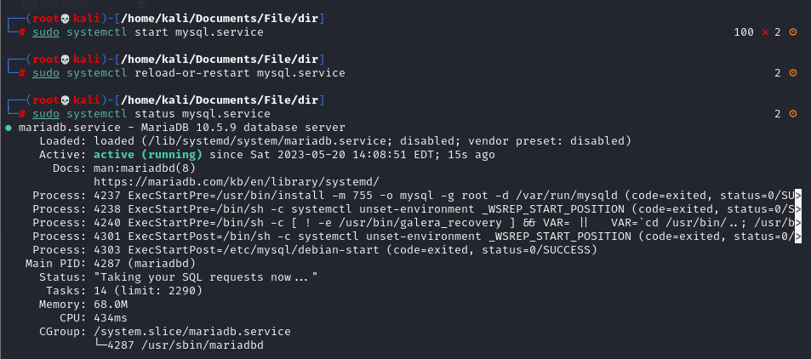

crontab: Schedule recurring tasks

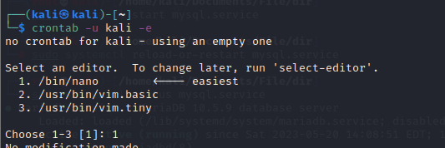

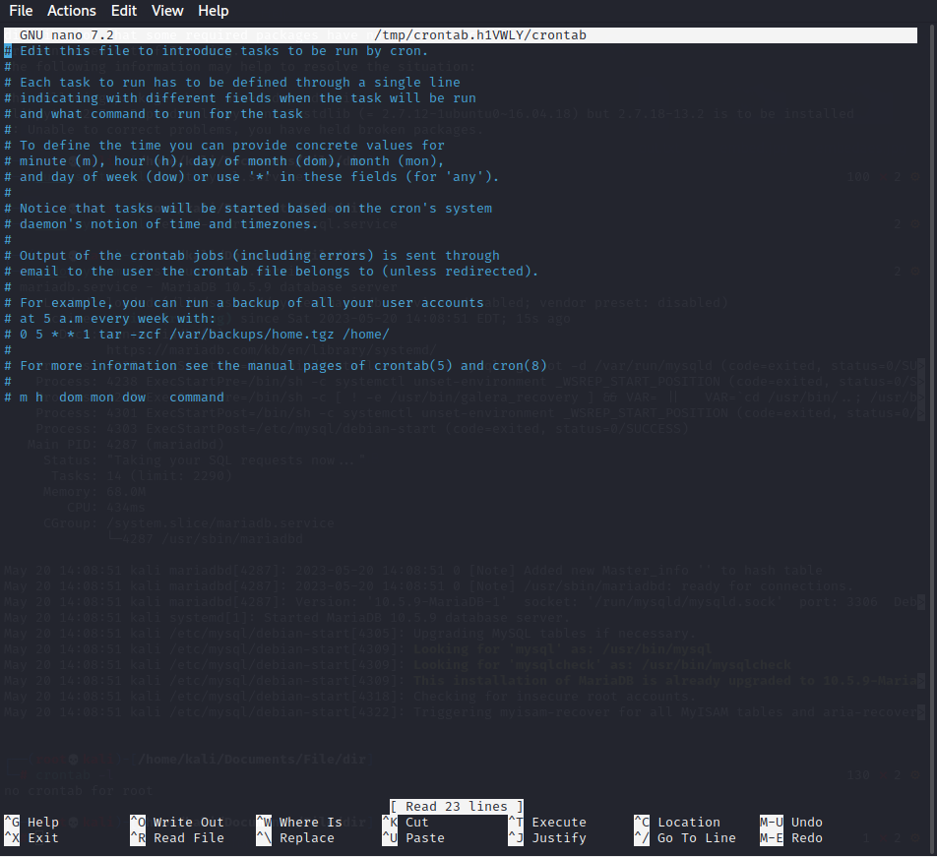

useradd: Add a new user



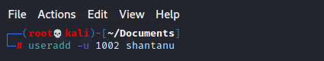

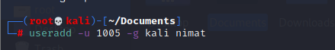

passwd: Change user password

